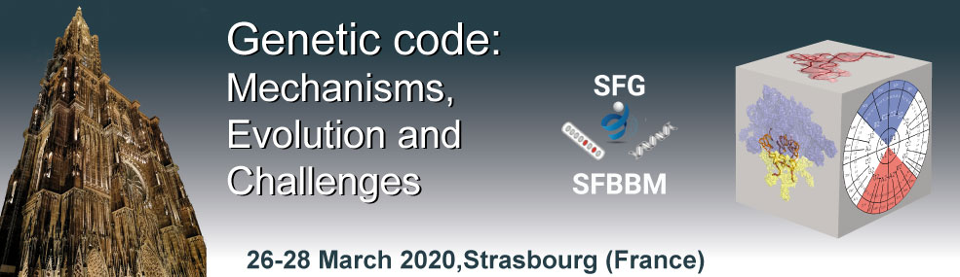
Centre culturel Saint Thomas, Strasbourg

Conference PROGRAM

Thursday, March 26

13:00 - 14:00 Arrival and Welcome coffee

14:00 - 14:15 Congress opening - Welcome address from the organizers

Session 1: Ribosome Structures and Decoding
Chair: Jean-Paul Renaud (Illkirch, France)

14:15 - 14:45 Marina Rodnina (Göttingen, Germany) - The EMBO Keynote Lecture
Decoding and recoding of genetic information by the ribosome
14:45 - 15:15 Daniel Wilson (Hamburg, Germany)
Rescue of ribosomes trapped on mRNAs without a stop codon
15:15 - 15:45 Eric Westhof (Strasbourg, France)
tRNA modifications in decoding: how to choose between two constraints

15:45 - 16:15 Coffee break

16:15 - 16:30 Talk 1 selected from abstracts
16:30 - 16:45 Talk 2 selected from abstracts
16:45 -17:00 Talk 3 selected from abstracts
17:00 -17:15 Talk 4 selected from abstracts

17:15 - 17:45 Sebastian Leidel (Bern, Switzerland)
Tuning translation by (RNA) modifications
17:45 - 18:15 Orna Dahan (Rehovot, Israel)
An interplay between the tRNA and mRNA pools affect translation efficiency and accuracy

18:30 Dinner

20:00 - 20:30 Young scientist session
Chair: Bojan Zagrovic (Vienna, Austria)
Echoes from the past: RNA-protein interactions and the structure of the genetic code
20:30 - 20:45 Talk 5 selected from abstracts
20:45 – 21:00 Talk 6 selected from abstracts

21:00 - 23:00 Poster session

Friday, March 27

Session 2: Translational Variations and Miscoding
Chair: Pascale Romby (Strasbourg, France)

9:00 - 9:30 Zoya Ignatova (Hamburg, Germany)– The French-German University (UFA) Keynote Lecture
Probing dimensionality beyond the linear sequence of mRNA
9:30 - 10:00 Olivier Namy (Saclay, France)
Stop codon readthrough as a tool to study the importance of tRNA modifications during decoding by near-cognate tRNAs

10:00 - 10:30 Coffee break

10:30 - 10:45 Talk 1 selected from abstracts
10:45 - 11:00 Talk 2 selected from abstracts

11:00 - 11:30 Ann Ehrenhofer-Murray (Berlin, Germany)
Queuosine tRNA modification and translational control in eukaryotes

12:00 - 14:00 Lunch

Session 3: Evolution and Code Optimization
Chair: Laurence Drouard (Strasbourg, France)

14:00 - 14:30 Barbara Nawrot (Lódz, Poland) - FEBS National Lecture
Another level of epitranscriptomics - how sulfur and selenium modified uridines in tRNA anticodons recognize A and G units in mRNA codons
14:30 – 15:00 Bernd Moosmann (Mainz, Germany)
Methionine: Key substrate and regulator of mitochondrial translation controlling metabolic health
15:00 – 15:30 Pierre Close (Liège, Belgium)
Codon-specific mRNA translation regulation through wobble tRNA modification in cancer

15:30 -16:00 Coffee break

16:00 - 16:15 Talk 1 selected from abstracts
16:15 - 16:30 Talk 2 selected from abstracts
16:30 -16:45 Talk 3 selected from abstracts
16:45 -17:00 Talk 4 selected from abstracts

17:00 – 17:30 Juliette Godin (Strasbourg, France)
Modifying tRNAs: a key process to regulate brain development?
17:30 – 18:00 Selected from abstracts : Jean-Pierre EBEL Keynote lecture

18:30 Dinner

20:00 - 20:30 Young scientist session
Chair: Mark Helm (Mainz, Germany)
Natural product chemistry on a tRNA scaffold
20:30 - 20:45 Talk 5 selected from abstracts
20:45 – 21:00 Talk 6 selected from abstracts

21:00 - 23:00 Poster session

Saturday, March 28

Session 4: Ribosome Engineering and Code Expansion
Chair: Bernard Dujon (Paris, France)

9:00 - 9:30 Valérie de Crécy-Lagard (Gainesville, USA) - IUBMB Jubilee Lecture
Synthesis and function of tRNA modifications
9:30 - 10:00 Joseph Moran (Strasbourg, France)
Linked chemical evolution of metabolism, RNA and the genetic code

10:00 - 10:30 Coffee break

10:30 - 10:45 Talk 1 selected from abstracts
10:45 - 11:00 Talk 2 selected from abstracts

11:00 - 11:30 Philippe Marlière (Evry, France)
Chemical evolution of genetic translation

11:30 – 11:45 Closing remarks

12:00 - 14:00 Lunch

End of meeting

